Machine generated alternative text:

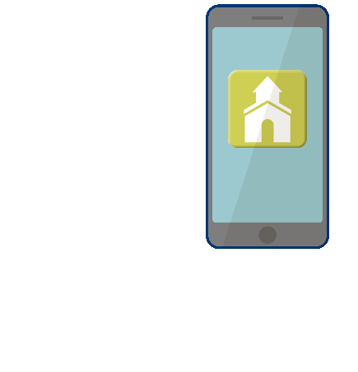

Our church directory is a great resource tool that allows you to get to know our church family better!

Simply go to the App Store, search for   
*Instant Church Directory* and download the FREE app to begin.

You will use your email address listed in the directory to CREATE A LOGIN the first time you use the directory app.

If you’re not listed in the directory, OR if you have trouble logging into the app, please contact the church office.

**VIEW OUR  
CHURCH   
DIRECTORY   
ON YOUR MOBILE DEVICE!**

FREE App for iPhone, iPad & Android