Machine generated alternative text:

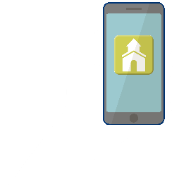

Our church directory is a great resource tool that allows you to get to know our church family better!

Simply go to the App Store, search for *Instant Church Directory* and download the FREE app to begin.

You will use your email address listed in the directory to CREATE A LOGIN the first time you use the directory app.

If you’re not listed in the directory, OR if you have trouble logging into the app, please contact the church office.

FREE App for iPhone, iPad & Android

**VIEW OUR  
CHURCH   
DIRECTORY  
ON YOUR  
MOBILE DEVICE!**